- Нұсқа
1.version: '3.9'

services:
db:
image: postgres:15
container_name: postgres_db
environment:
POSTGRES_USER: student
POSTGRES_PASSWORD: secret
POSTGRES_DB: university
ports:
- "5432:5432"
volumes:
- pgdata:/var/lib/postgresql/data

web:
image: python:3.10
container_name: flask_app
working_dir: /app
volumes:
- ./backend:/app
command: bash -c "pip install -r requirements.txt && python app.py"
ports:
- "5000:5000"
depends_on:
- db
environment:
DB_HOST: db
DB_NAME: university
DB_USER: student
DB_PASS: secret

volumes:
pgdata:

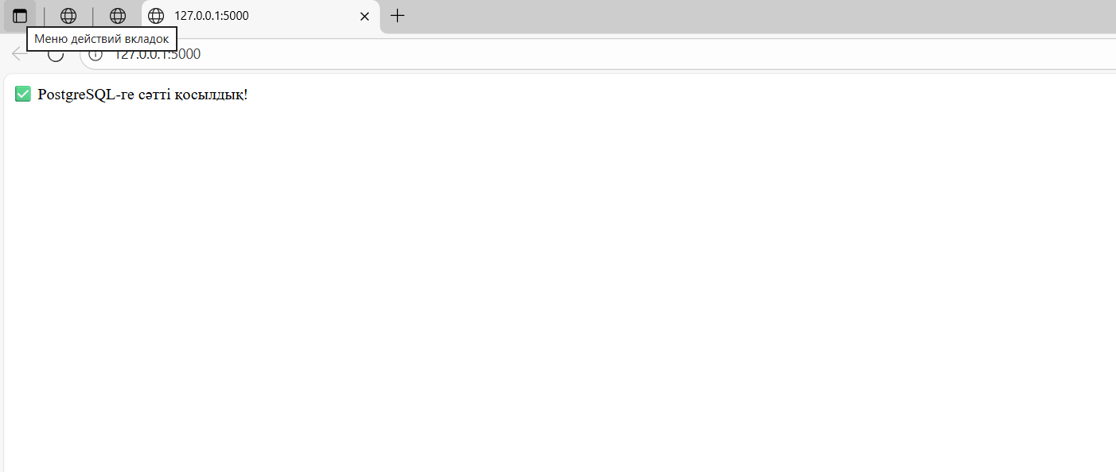

2.
